Experiment 2: Bus Ticket Booking System Using Figma
AIM
To design a simple prototype of a Bus Ticket Booking System using the Figma tool.
PROCEDURE
- Open Figma and create a new design file.
- Create a mobile frame for the application screen.
- Design the Bus Ticket Booking System home screen.
- Add the following details:
  - From
  - To
  - Journey Date
  - Search Buses button
- Create an Available Buses screen.
- Add sample bus details such as:
  - Bus name
  - Departure time
  - Arrival time
  - Ticket price
- Add a Select Seats button for the available buses.
- Create a Passenger Details screen with fields such as name, age, gender and mobile number.
- Create a Booking Confirmation screen.
- Use the Prototype option in Figma to connect the screens and simulate the booking flow.
- Test the prototype using the Present/Play option.

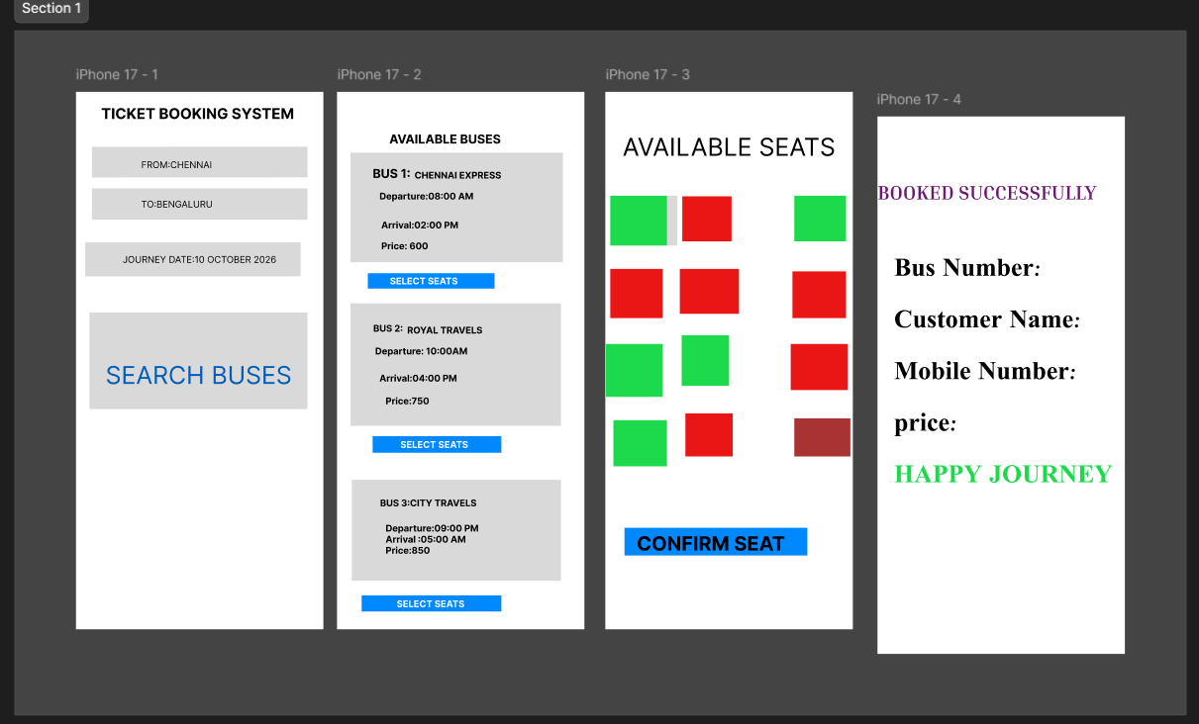

RESULT
A simple Bus Ticket Booking System prototype was successfully designed using Figma, with multiple screens connected to demonstrate the bus booking workflow.

